Software Requirements Specification
for
QR Code Attendance Application
Prepared by The Golden Dragons
10/10/2025

Table of Contents
Table of Contents......................................................................................................... ii
Revision History........................................................................................................... ii
1. Introduction............................................................................................................ 1
1.1 Purpose................................................................................................................ 1
1.2 Document Conventions......................................................................................... 1
1.3 Intended Audience and Reading Suggestions.......................................................... 1
1.4 Product Scope....................................................................................................... 1
1.5 References........................................................................................................... 1
2. Overall Description................................................................................................ 2
2.1 Product Perspective............................................................................................... 2
2.2 Product Functions................................................................................................. 2
2.3 User Classes and Characteristics............................................................................ 2
2.4 Operating Environment......................................................................................... 2
2.5 Design and Implementation Constraints................................................................. 2
2.6 User Documentation............................................................................................. 2
2.7 Assumptions and Dependencies............................................................................. 3
3. External Interface Requirements......................................................................... 3
3.1 User Interfaces..................................................................................................... 3
3.2 Hardware Interfaces.............................................................................................. 3
3.3 Software Interfaces............................................................................................... 3
3.4 Communications Interfaces................................................................................... 3
4. System Features..................................................................................................... 4
4.1 System Feature 1.................................................................................................. 4
4.2 System Feature 2 (and so on)................................................................................. 4
5. Other Nonfunctional Requirements..................................................................... 4
5.1 Performance Requirements.................................................................................... 4
5.2 Safety Requirements............................................................................................. 5
5.3 Security Requirements.......................................................................................... 5
5.4 Software Quality Attributes................................................................................... 5
5.5 Business Rules..................................................................................................... 5
6. Other Requirements.............................................................................................. 5
Appendix A: Glossary.................................................................................................. 5
Appendix B: Analysis Models..................................................................................... 5
Appendix C: To Be Determined List.......................................................................... 6

Revision History
Name | Date | Reason For Changes | Version
Austin Monroe | 11/8/25 | To reflect necessary app changes | v1.1
Austin Monroe | 12/8/25 | To reflect necessary app changes | v1.2

1. Introduction

1.1 Purpose
This Software Requirements Specification (SRS) defines the functional, non-functional, and system requirements for the QR-Based Attendance Web Application.
The system enables instructors to create and manage classes, rosters, and attendance sessions using QR codes, and allows students to check in and view their attendance.
This revised SRS reflects the final implemented system running on a PHP/MySQL stack via XAMPP.

1.2 Document Conventions
Functional requirements are labeled F#.# (e.g., F1.1, F3.5).
Non-functional requirements are labeled NF#.#.
“The System” refers to the QR Attendance web application, including teacher and student dashboards and backend APIs.

1.3 Intended Audience and Reading Suggestions
• Developers: maintain and extend the PHP, JavaScript, and SQL codebase.
• Testers: design and execute test cases to confirm conformance with this SRS.
• Instructors and stakeholders: understand the capabilities and limitations of the system.
• Evaluators: compare project deliverables with requirements.
Suggested reading:
• Section 2 for overview.
• Section 4 for detailed behavior.
• Sections 5–6 for quality and deployment aspects.

1.4 Product Scope
The product is a local web application used to manage attendance via QR codes.
Instructors can:
• Create classes and manage rosters.
• Create, open/close, and delete sessions.
• Generate QR codes for sessions.
• View and export attendance and history in CSV format.
Students can:
• Log in.
• Scan QR codes to check in to open sessions.
• View attendance for their enrolled classes.
• Export their own attendance in CSV format.
The current implementation targets a single-machine, local-network deployment using XAMPP on Windows. Institutional deployment with SSO, HTTPS, and FERPA compliance is considered future work.

1.5 References
QR-Based Attendance App: Requirements Specification by Austin Monroe (v1.2, 2025).
IEEE Software Requirements Specification Template by Karl E. Wiegers (1999).
QR-Based Attendance Use Case Document by Austin Monroe (v1.0, 2025)

2. Overall Description

2.1 Product Perspective

The system is a standalone web application running on XAMPP (Apache, PHP, MySQL).
It does not integrate with institutional SSO or LMS systems in the current implementation.
QR tokens are generated server-side, while QR images are rendered using a lightweight third-party service.
All token validation and attendance recording occurs in the local backend.

2.2 Product Functions
Key functions include:
• Unified login page for all users; role-based redirection to instructor or student dashboard.
• Instructor dashboard with cards for classes, roster, sessions, QR token generation, attendance, and history.
• Student dashboard with profile summary, “My Classes”, per-class attendance details, and recent check-ins.
• Token-based QR attendance check-in for logged-in students on the roster.
• CSV exports for instructors (session-level and class-level) and for students (per-class attendance).
• Logging of login attempts and system errors.
• Recording IP address and user agent for each attendance check-in.

2.3 User Classes and Characteristics
• Students – authenticate with email/password, scan QR codes and view their attendance. Limited to student features.
• Instructors – authenticate with email/password, manage classes/rosters/sessions, view and export attendance. Limited to instructor features.
Both user classes are assumed to be familiar with basic browser operations. No special technical skills are required.

2.4 Operating Environment
• Server: Windows 10/11 running XAMPP (Apache, PHP 8.x, MySQL).
• Client: Modern web browsers (Chrome, Edge, Firefox, Safari) on desktop or mobile.
• Network: Local network (LAN/Wi-Fi) such that students’ devices can reach the server via its IP address.
• Protocol: HTTP in the current prototype; HTTPS/TLS reserved for future production deployment.

2.5 Design and Implementation Constraints
• Implementation language: PHP 8.x for backend, JavaScript (ES6) for frontend.
• Database: MySQL with the schema defined in qr_application_db.sql.
• Deployment: XAMPP stack; no external application servers.
• Authentication: custom credential store; SSO is not used.
• No production HTTPS/TLS in this version; treated as a future deployment concern.

2.6 User Documentation
• Inline hints and tooltips are provided on the dashboards.
• A brief user guide may be supplied separately but is not part of this SRS.

2.7 Assumptions and Dependencies

• All users share the same local network when QR scanning (phones must reach the server).
• The external QR image generator service remains available.
• JavaScript is enabled in browsers.

3. External Interface Requirements

3.1 User Interfaces
Login Page
• Single login form for all users requesting email and password.
• On success, redirect based on role to the instructor or student dashboard.
• On failure, show an error message and log the attempt.
Instructor Dashboard
• Card-based layout with distinct sections:
- Classes: list/create/rename/delete classes, showing per-class student and session counts.
- Roster: view students in a class; add students by email (must have existing student account); remove students.
- Sessions: list sessions per class, create new sessions, open/close sessions, delete sessions, and generate QR tokens.
- Attendance: view roster students and their present/absent status for a selected session; allow manual overrides.
- History: show session history for a class with present/absent counts and filters; export CSV.
Student Dashboard
• My Profile: shows student name, count of enrolled classes, and overall attendance percentage.
• My Classes: lists enrolled classes with per-class attendance percentage and total sessions.
• Attendance Details: selects a class and optional date range to show session-by-session present/absent status; CSV export for that student and class.
• Recent Check-ins: lists recent successful attendance check-ins with class, session description, and timestamp.

3.2 Hardware Interfaces
The system operates entirely through standard computing and mobile devices with internet access — no specialized hardware is required.
Instructor Hardware Requirements:
- Desktop or laptop computer with a modern web browser (preferably Google Chrome).
- Reliable internet connection.
Student Hardware Requirements:
- Smartphone, tablet, or laptop with a built-in camera capable of scanning QR codes.
- Internet connection sufficient to load the attendance webpage.
Server Hardware Requirements:
- Web server capable of hosting the web application and MySQL database
- Recommended minimum specifications:
  - Quad-core processor (2.0 GHz or higher).
  - 8 GB RAM.
  - 100 GB storage space.
  - Stable network connection supporting HTTPS communication.
All communication between user devices and the server will occur via standard web protocols (HTTP/HTTPS).

3.3 Software Interfaces
• Backend: PHP code using PDO to interact with MySQL.
• Database: MySQL schema including tables app_user, class, roster, class_session, qr_token, attendance, attendance_audit (optional), login_log, system_log.
• External QR generator: HTTP-based QR image generation service (e.g., api.qrserver.com).
• Frontend: HTML5/CSS/JavaScript communication via JSON APIs.

3.4 Communications Interfaces

• HTTP over LAN/Wi-Fi between clients and server.
• JSON for API responses from endpoints such as api/auth.php, api/classes.php, api/sessions.php, api/attendance.php, api/student.php, api/export.php, api/qr.php, api/history.php, and api/roster.php.
• HTTPS/TLS is not used in this prototype but is expected in future institutional deployments.

4. System Features

4.1. Instructor Dashboard and Session Management
4.1.1 Description and Priority
Instructors manage classes, rosters, sessions, QR tokens, and attendance from a unified dashboard.
Priority: High
4.1.2 Stimulus/Response Sequences
- Stimulus: Instructor logs in and opens the Classes card.
Response: System displays all classes owned by that teacher with student/session counts.
- Stimulus: Instructor creates a new session for a class.
Response: System creates a class_session row, visible in Sessions card.
- Stimulus: Instructor clicks “Generate QR” for a session.
Response: System creates/refreshes a QR token for that session and displays a QR image whose URL points to the student check-in endpoint.
- Stimulus: Instructor selects a session to view attendance.
Response: System shows roster students with their present/absent status.
- Stimulus: Instructor exports session or class history.
Response: System generates a downloadable CSV file.
4.1.3 Functional Requirements
- F1.1 – The system shall allow instructors to create and name new classes and sessions.
- F1.2 – The system shall generate a unique, session-specific QR token linked to a check-in page URL.
- F1.3 – The system shall store session data in the database (class_session table).
- F1.4 – The system shall display, for each session, the list of rostered students and whether they are present or absent.
- F1.5 (UPDATED) – The system shall allow instructors to export attendance reports in CSV format (session-level and class-level).
- F1.6 – The system shall ensure that at most one active QR token exists per session at a time (new tokens supersede previous ones).
- F1.7 – The system shall display clear error messages if session creation, token generation, or database access fails.

4.2 Student Attendance Check-In
4.2.1 Description and Priority
Students log in, then scan QR codes displayed by instructors to check in to open sessions. The system identifies the student based on their authenticated account, not by manually entered name/ID.
Priority: High
4.2.2 Stimulus/Response Sequences
- Stimulus: Student scans session QR with phone camera and opens the link.
Response: System loads the check-in page, reads the QR token from the URL, and validates it.
- Stimulus: Student is logged in and is on the class roster for that session.
Response: System records attendance (if not already recorded) and shows a success message.
- Stimulus: Student scans QR for an invalid/closed session or is not on that class roster.
Response: System displays an error message and does not record attendance.
4.2.3 Functional Requirements
- F2.1 – The system shall accept QR tokens from mobile or desktop browsers via URL parameters.
- F2.2 (UPDATED) – After scanning the QR code, the system shall identify the student from their current login session instead of asking for name/ID.
- F2.3 – The system shall record each student’s attendance in the attendance table with timestamp, IP address, and user agent.
- F2.4 – The system shall prevent duplicate attendance records for the same student and session.
- F2.5 – The system shall notify the student upon successful check-in or if they are already marked present.
- F2.6 – The system shall reject attendance submissions if the session is not open or if the token is invalid/expired.

4.3 Authentication and Authorization
4.3.1 Description and Priority
The system uses a single login page but enforces role-based access after authentication. No SSO is used; authentication is internal.
Priority: High
4.3.2 Stimulus/Response Sequences
- Stimulus: User submits email and password on login page.
Response: System validates credentials, determines role, and routes the user to the appropriate dashboard.
- Stimulus: User attempts to access a teacher/students dashboard without being logged in or with wrong role.
Response: System redirects to login and/or denies access.
4.3.3 Functional Requirements
- F3.1 (UPDATED) – The system shall provide a single login page for all users and route them to the appropriate dashboard based on their role (student or teacher).
- F3.2 – The system shall validate credentials against the app_user table using securely hashed passwords.
- F3.3 – The system shall restrict student accounts to student dashboard features only.
- F3.4 – The system shall restrict instructor accounts to instructor dashboard features only.
- F3.5 – The system shall log all login attempts (success and failure) to the login_log table, including timestamp, IP, and user agent.

4.4 Attendance Reporting and Data Management
4.4.1 Description and Priority
Instructors can view, filter, and export attendance for sessions and whole classes. Students can see and export their own attendance.
Priority: Medium
4.4.2 Stimulus/Response Sequences
- Stimulus: Instructor selects “History” for a class.
Response: System displays a table of sessions with present/absent counts and date filters.
- Stimulus: Instructor exports session history for a class.
Response: System generates a CSV file for download.
- Stimulus: Student exports attendance for a class.
Response: System generates a CSV file containing that student’s attendance in the selected class.
4.4.3 Functional Requirements
- F4.1 – The system shall display attendance history (sessions, dates, counts) in tabular form on the instructor dashboard.
- F4.2 – The system shall allow instructors to filter history by class and date range.
- F4.3 (UPDATED) – The system shall allow instructors and students to export attendance data to CSV format only.
- F4.4 – The system shall compute attendance summaries (e.g., total present/absent per session or per student within a class).

4.5 Error Handling and Security Controls
4.5.1 Description and Priority
The system should fail gracefully, protect against common web vulnerabilities, and log critical errors.
Priority: High
4.5.2 Stimulus/Response Sequences
- Stimulus: API call throws an unexpected exception (e.g., DB failure).
Response: System returns a 500-level error to the client and logs details to system_log.
- Stimulus: Student attempts check-in with invalid/expired QR token.
Response: System returns an error message explaining that the session is closed or token is invalid.
4.5.3 Functional Requirements
- F5.1 – The system shall validate user input for presence and format server-side and client-side where appropriate.
- F5.2 – The system shall handle invalid or expired QR tokens with clear error messages to the user.
- F5.3 (MODIFIED SCOPE) – In the current prototype, sensitive data is transmitted over HTTP in a trusted local network; use of HTTPS/TLS is reserved for future deployment.
- F5.4 – The system shall log major system errors (e.g., unhandled exceptions, failed DB operations) to the system_log table.
- F5.5 – The system shall mitigate SQL injection and XSS by using prepared statements (PDO) and proper escaping of dynamic content.

5. Other Nonfunctional Requirements
5.1 Performance Requirements
- NF1.1 – Common operations (dashboard loads, list classes/sessions, view attendance) should complete in under 2 seconds on a local network.
- NF1.2 – Attendance check-in (QR → record inserted) should complete within ~2 seconds.
- NF1.3 – CSV exports should generate in under ~5 seconds for typical class sizes (< several hundred records).
5.2 Safety Requirements
- NF2.1 – Attendance data shall be stored safely in MySQL; partial failures should not corrupt tables.
- NF2.2 – Deletion operations (classes, sessions) are confirmed via UI and implemented with transactions where appropriate.
- NF2.3 – Future institutional deployments may implement scheduled backups and archival policies; the current local prototype assumes manual backup of the MySQL database.
5.3 Security Requirements
- NF3.1 – Passwords shall be stored using secure hashing (e.g., password_hash in PHP).
- NF3.2 – Access to instructor endpoints requires role = teacher; student endpoints require role = student.
- NF3.3 – Login attempts and system errors are logged for audit and debugging.
- NF3.4 – For institutional deployment, FERPA compliance, SSO, and mandatory HTTPS/TLS will be treated as additional requirements beyond this prototype.
5.4 Software Quality Attributes
- Usability – Dashboards use clear labels, consistent components, and basic tooltips.
- Reliability – Attendance records avoid duplicates; missing attendance is represented by absence of rows.
- Maintainability – Code is organized into API endpoints (api/*.php) and backend helpers (backend/*.php).
- Scalability – The schema supports multiple teachers, classes, and sessions; performance constraints are acceptable for typical class sizes.
5.5 Business Rules
- Only users with role = teacher may create classes, sessions, and QR tokens.
- Students may check in only once per session and only for sessions that are open.
- Session open/close is controlled manually by instructors (no automatic 24-hour lock).
- The system records timestamp and device information (IP address and user agent) for each student check-in.
- Attendance retention and archival policies for institutional use are considered future deployment requirements.

6. Other Requirements
6.1 Database Requirements
- A MySQL relational schema stores users, classes, rosters, sessions, tokens, and attendance.
- Referential integrity is enforced via foreign keys (e.g., sessions → class, attendance → session & student).
- Passwords are hashed and never stored in plaintext.
- Data volume expected for this prototype is within a few thousand records; schema is suitable for modest scaling.
6.2 Security and Legal Requirements
- The system is currently used in a controlled, local environment; institutional security/legal requirements (FERPA, official SSO, HTTPS/TLS) are acknowledged but not implemented in this version.
- Role-based access control (RBAC) is enforced at the application level.
6.3 Internationalization
- English is the default and only language for the current system.
- The UI and code structure allow additional languages to be added in future iterations.
6.4 Reuse Objectives
- QR token generation and verification are encapsulated in dedicated backend code and can be reused for other campus check-in workflows (events, exams).
- Core attendance logic (sessions, roster, attendance storage, logging) is modular and can be extended or integrated with other systems (e.g., LMS) in the future.

Appendix A: Glossary
Term / Acronym | Definition
QR Code (Quick Response Code) | A two-dimensional barcode that stores encoded information (e.g., attendance ID, timestamp) readable by mobile devices.
SRS | Software Requirements Specification — a detailed description of the system’s intended functionality and constraints.
FERPA | Family Educational Rights and Privacy Act — U.S. law that protects student education records and privacy.
RBAC | Role-Based Access Control — a security method that restricts system access based on user roles.
HTTPS | Hypertext Transfer Protocol Secure — a secure version of HTTP that encrypts data during transmission.
Admin | A user role with full access to manage users, attendance records, and system configurations.
Student | A user who attends classes and scans QR codes to mark attendance.
Instructor | A user responsible for generating QR codes and reviewing attendance data.
Database | Structured storage used to manage and retrieve system data.

Appendix B: Analysis Models
This section includes visual and conceptual models representing the system’s internal structure and flow. (Diagrams can be attached here.)
- Activity Diagram: Shows the activity between the actors Student, Teacher, and the system,
- Class Diagram: Draws all the classes needed to meet functional requirements as well as their relationships
- Use Case Diagram: Illustrates the interactions between students, instructors, and the system.

- Sequence Diagram: Displays step-by-step processes for attendance marking (both instructor and student perspectives).
Activity Diagram
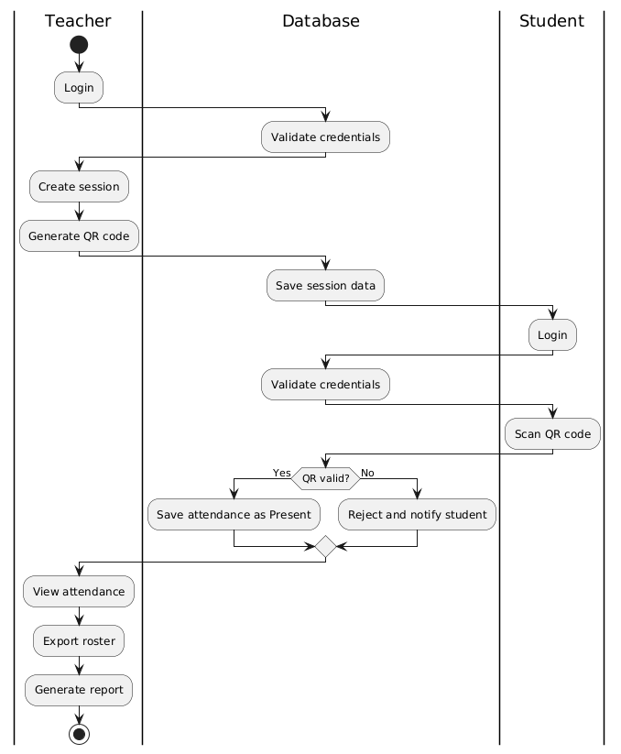

Class Diagrams
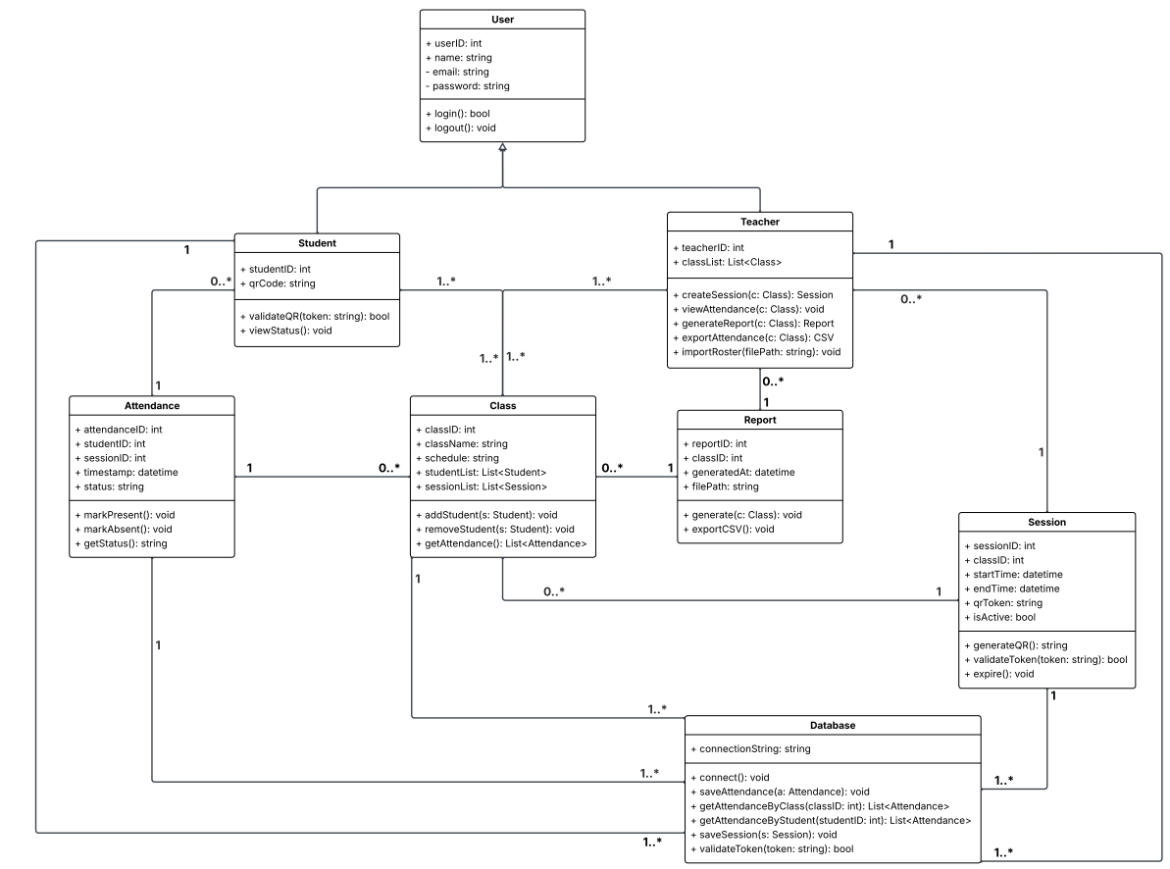

Use Case
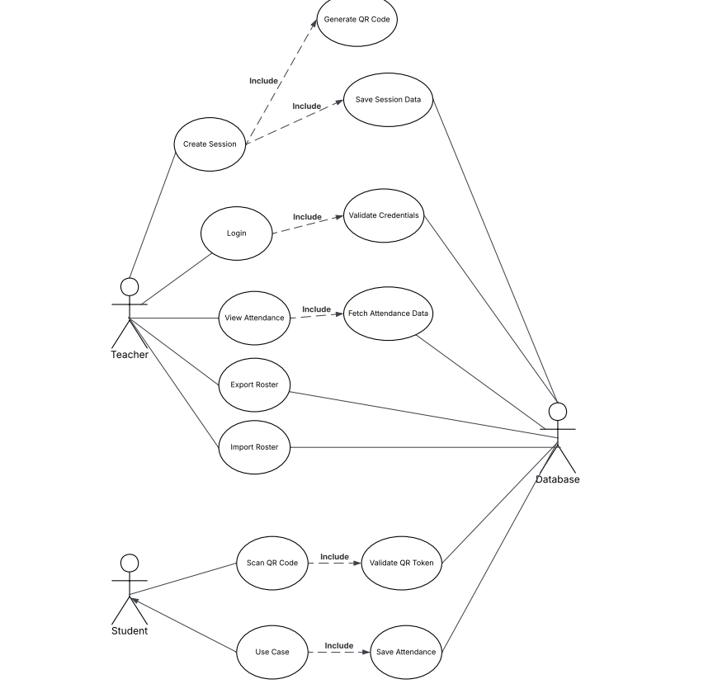

Sequence
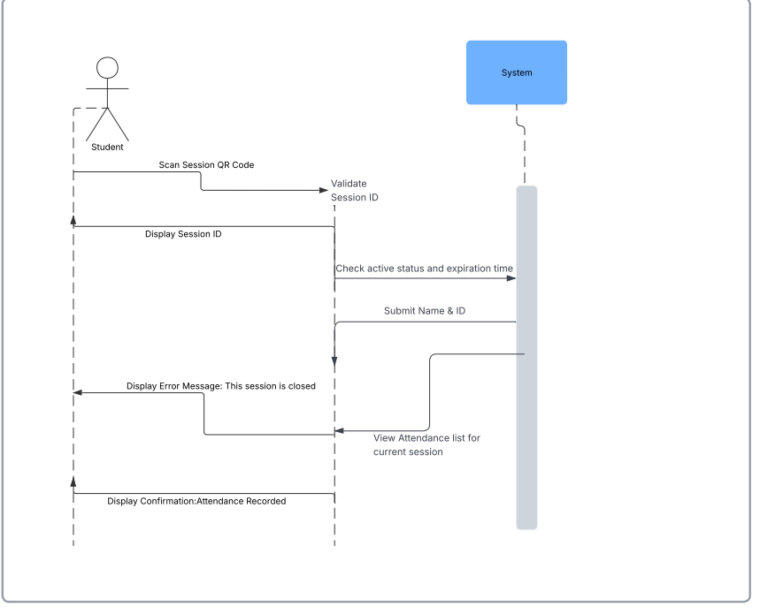
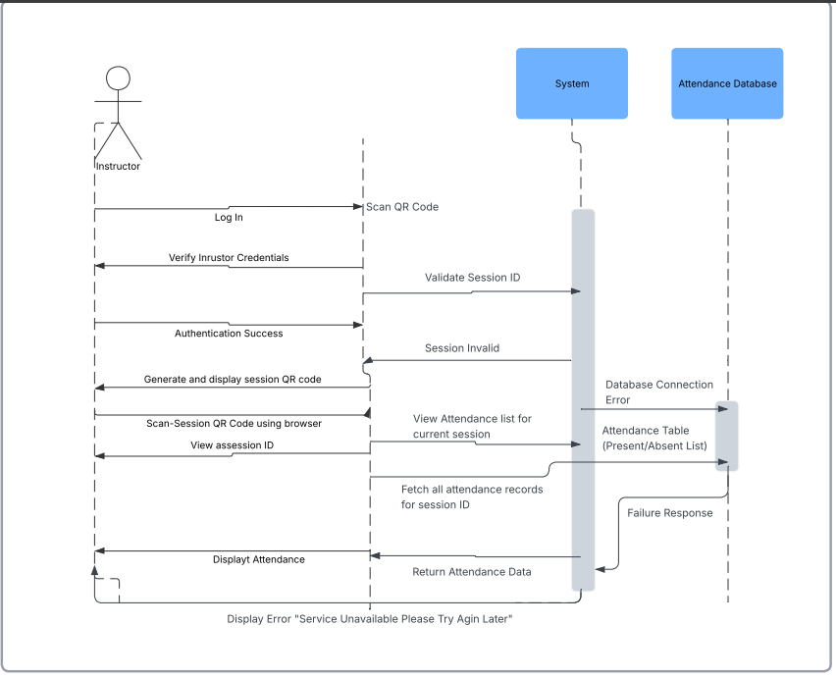

Appendix C: Functional Requirement Implementation
Requirement ID | Description | Implementation (Files/Endpoints)
F1.1 | Create and name classes and sessions | api/classes.php:create, api/sessions.php:create, teacher_dashboard.html
F1.2 | Generate session-specific QR tokens | api/qr.php:create, teacher_dashboard.html
F1.3 | Store session data | class_session table, api/sessions.php
F1.4 | Display attendance per session | api/attendance.php:list, teacher_dashboard.html
F1.5 | Export attendance as CSV | api/export.php (session_csv, class_csv), teacher_dashboard.html
F1.6 | Ensure at most one active QR token per session | api/qr.php:create, qr_token table
F1.7 | Error messages on failure in instructor operations | teacher_dashboard.html UI, api/classes.php, api/sessions.php
F2.1 | Accept QR tokens via URL | public/checkin.html
F2.2 | Identify student based on authenticated login, not manual ID | checkin.php, auth.php
F2.3 | Record attendance with timestamp, IP, and user agent | checkin.php (INSERT), attendance table
F2.4 | Prevent duplicate attendance per student/session | checkin.php logic / DB constraints
F2.5 | Notify student of success or already-present status | public/checkin.html UI
F2.6 | Reject invalid/expired/closed session tokens | checkin.php, qr_token table
F3.1 | Unified login page with role-based routing | index.php (login), auth.php
F3.2 | Secure credential validation | auth.php with password_hash/password_verify, app_user table
F3.3 | Student role restrictions | student_dashboard.html, api/student.php, role checks in PHP
F3.4 | Instructor role restrictions | teacher_dashboard.html, api/classes.php, api/sessions.php, api/attendance.php, api/history.php, api/export.php
F3.5 | Log login attempts | auth.php (login), login_log table
F4.1 | Display attendance history (instructor view) | api/history.php, teacher_dashboard.html
F4.2 | Filter history by class and date | History filter UI in teacher_dashboard.html, parameters to api/history.php
F4.3 | CSV export for instructor and student | api/export.php (session_csv, class_csv, student_csv), teacher & student dashboards
F4.4 | Compute attendance summaries | api/history.php, api/student.php summary fields
F5.1 | Validation of user inputs | auth.php, classes.php, sessions.php, attendance.php, roster.php, student.php
F5.2 | Handle invalid QR tokens gracefully | checkin.php, public/checkin.html
F5.3 | HTTPS/TLS reserved for future deployment | Deployment / ops documentation (not in code)
F5.4 | System error logging | logging.php (log_system_error), system_log table, catch blocks in api/*.php
F5.5 | Mitigate SQL injection and XSS | Prepared PDO statements across api/*.php, careful rendering in dashboards

